***Proposal on***

“Quiz Master”

## Prepared for:

### Dr. Taslim Taher Assistant Professor

**Md. Nafis Fuad Lecturer**

**Course Number & Name:**

**CSE 3224 - Information & System Design Lab**

## Prepared by:

### Lab Section: B1 Group No: 1

#### HRIDITA BARUA ID: 20200104052

**JANNATUL MAOWA AHONA ID: 20200104055**

#### SOWPNIL ROY ID: 20200104071

***Date: 28.05.2023***



## Ahsanullah University Of Science & Technology

***Department of Computer Science and Engineering***

Project Overview:

Our Project is on quiz game app is to provide an enjoyable and interactive experience for players while testing their knowledge and challenging them to answer questions correctly. The goal of a quiz game app is to provide an enjoyable and interactive experience for players while testing their knowledge and challenging them to answer questions correctly.

Construction

 Development Environment

● Platform: Android Studio 2022.2.1.20

● Language: JAVA

● Database: Firebase

User Story:

**As a quiz game player,** I want to test my knowledge and have fun, so that I can challenge myself and compete with others.

Acceptance Criteria:

* The app should provide different categories of questions, such as history, science, sports, movies, and more.
* I should be able to select a category and start a quiz session.
* The app should present multiple-choice questions with clear and concise options.
* The app should provide the feedback that the answer is correct or incorrect after completing all the question.
* I should be able to see my score after completing all question and track my overall progress.
* The app should display a leaderboard with the top scores of all players.
* I should be able to share my scores and achievements on social media platforms.
* The app should have an intuitive and user-friendly interface for smooth interaction.

**As a quiz game player,**

I want to have a personalized experience, so that I can track my performance, earn achievements.

Acceptance Criteria:

* The app should allow me to create an account (Registration) or log in.
* I want to select one option as the answer.
* I want to change the selected answer before moving to the next questions.
* I want to see my previous quiz history, including scores.
* I want the option to customize my profile and display a unique username or avatar.

Module breakdown

**1.User Module:**

* **User registration and login:** Allows users to registration by using email address and password. Then log in to the application using username and password by accessing the database.
* **User profile management:** Allows users to control the management of their profile**.**
* **Progress tracking and history:** Measuring progress is important because it allows user to see how far they've come and how close they are to reaching their goal.

**2.Admin Panel Module:**

* Administrative interface for managing categories and questions
* User management and access control for administrators
* Monitoring user activity and quiz statistics

**3.Leaderboard Module:**

* Storing and updating scores of players
* Displaying top scores
* Ranking players based on their scores

**4.User Interface Module:**

* Designing and implementing the user interface for the app
* Layouts for quiz sessions, leaderboard, user profiles, and achievements

**5.Firebase Management Module:**

* Storing and retrieving user data, including profiles, scores, and progress
* Managing the question bank and category information

**6.Log out & System Termination module:**

**● Log Out:** Allows the users to log out of the application and shows the

login interface.

**● Close app:** players can terminate or close the whole application.

Collaboration Matrix

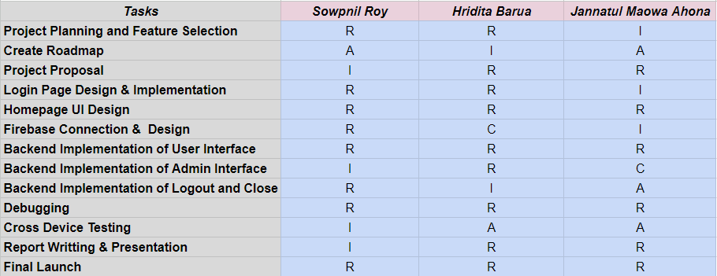

**R =** Responsible for the Task

**A =** Accountable for the overall success or failure of the Task

**C =** Consulted for the expertise

**I =** Decision

Gantt Chart

The Gantt chart presented below provides a visual representation of the project schedule for the Development of our Quiz Game.

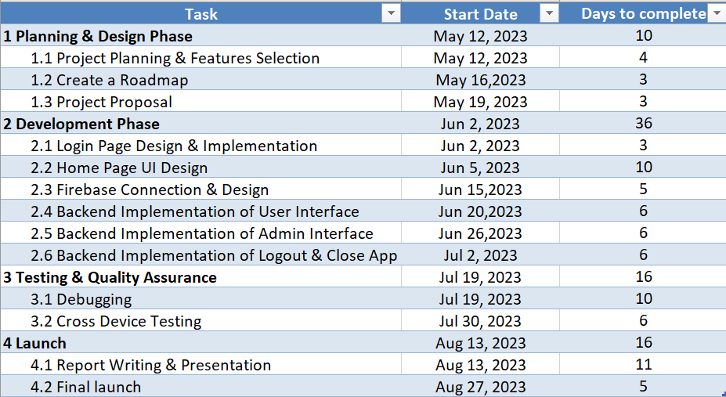

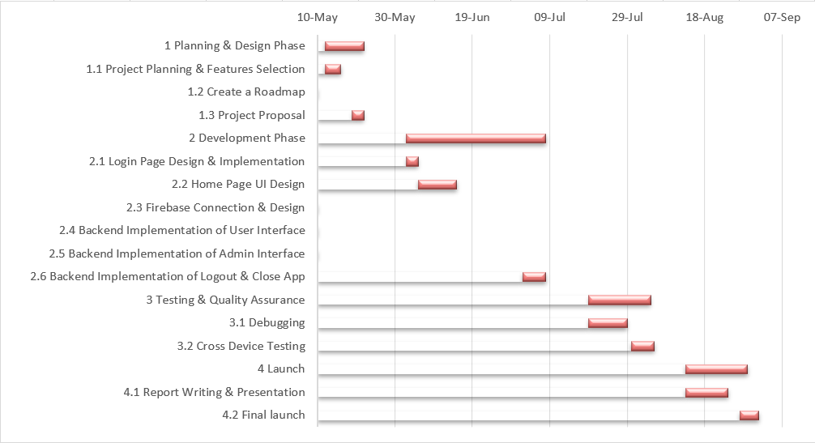

User Stories and Relevant UI:

**As a player,**

* I want to be able to log in to the Quiz Master app so that I can access the necessary features and perform my duties effectively. I should be successfully logged into the app directly using my google account that all the information’s of the players store in the firebase system.



***Fig: Sign in UI***

* Here, by implementing this Login UI we can accomplish this user story.

**As a player,**

* At home page, I can be able to enter the Quiz List categories in the Quiz Master app. Categorizing them according to different type of subjects such as-Subjects, My List, Test, Profile, Sign Out
* By entering these categories I can play quiz of my preferable subject and get relatable information about my playing skill and quiz app.



***Fig: Home page UI***

**As a player,**

* I can be able to choose in which subject I want to play for quiz. Let I want to play quiz for Mathematics. So, I have to enter this category and there will be some options about Algebra, Calculus, Discrete Mathematics etc.
* If I want to go to the next page, I have to select any option of these and click it.

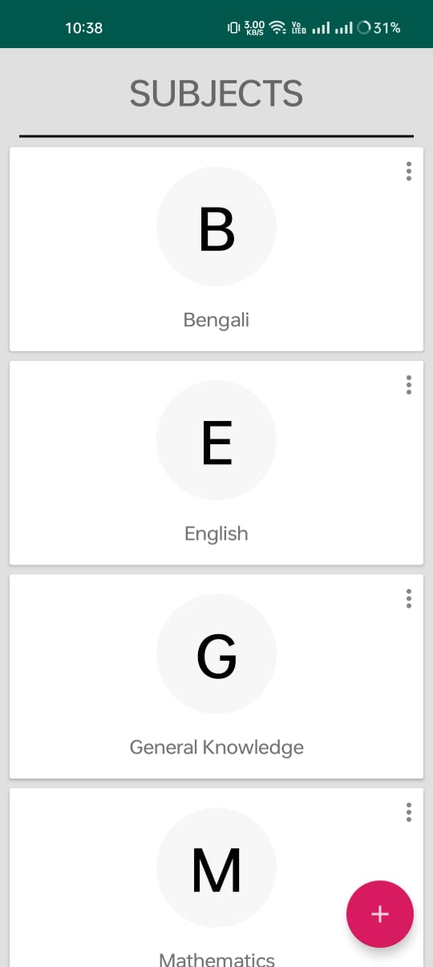

***Fig: Subjects UI***

Use case diagrams:

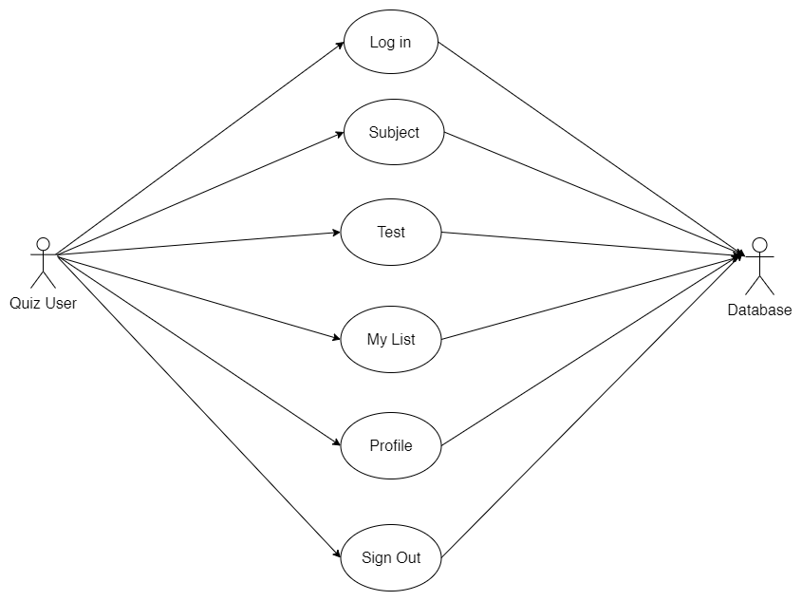

**Swimlane diagrams:**

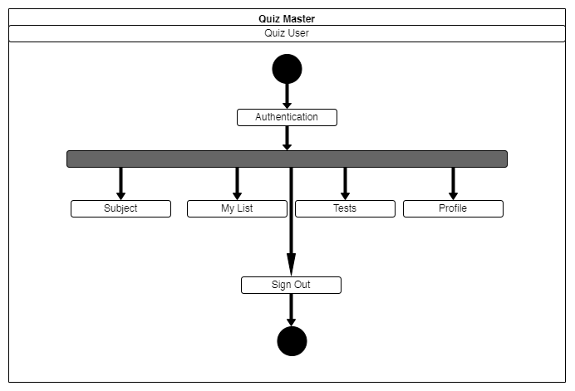

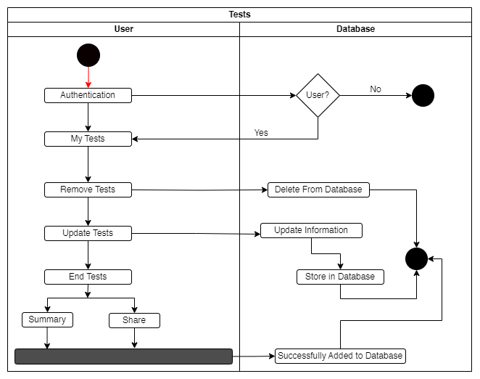

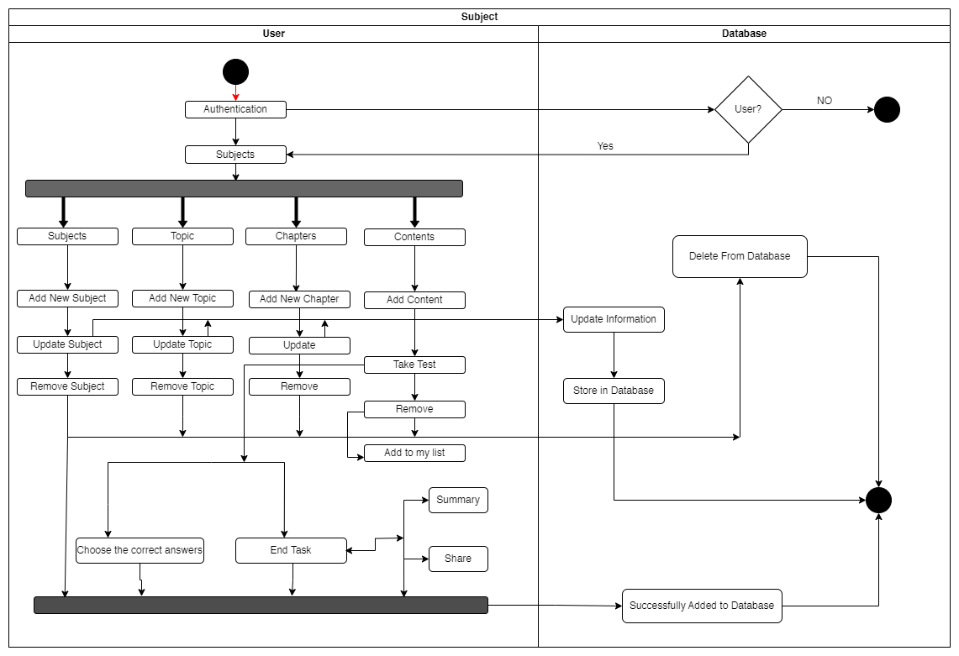

Class diagram:

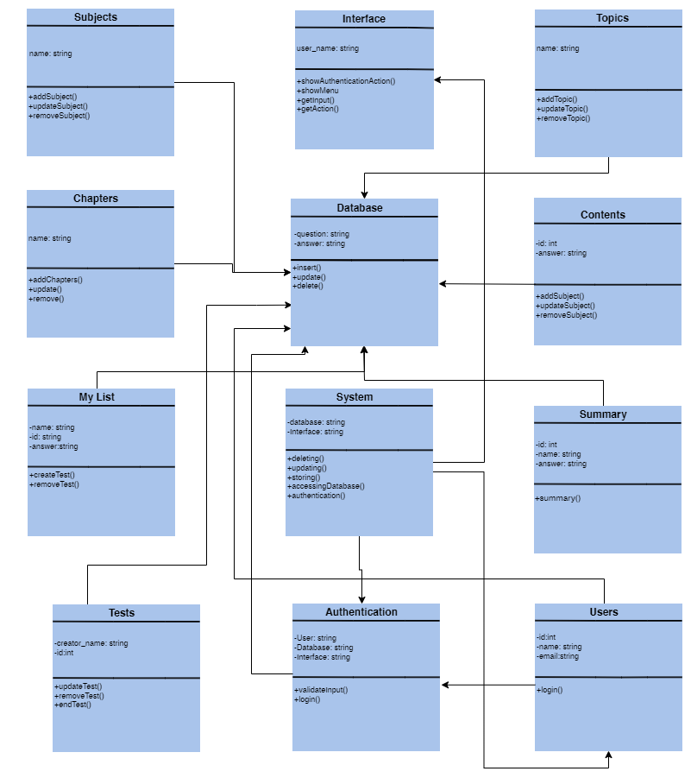

State diagrams:

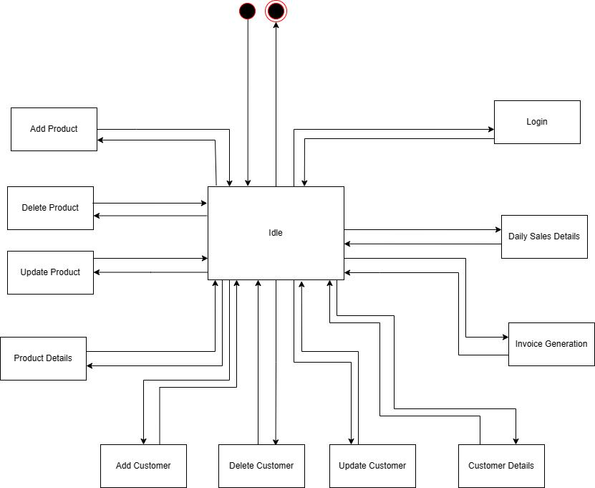

***Fig(1***)

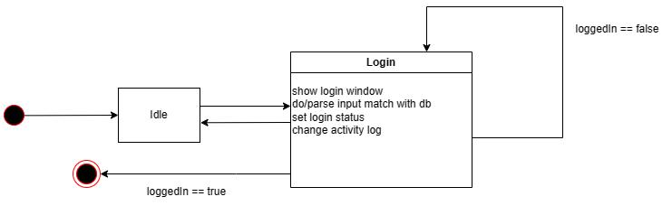

***Fig(2***)

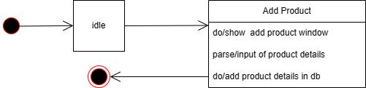

***Fig(3***)

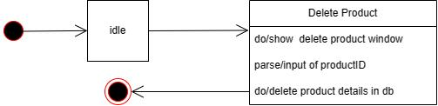

***Fig(4***)

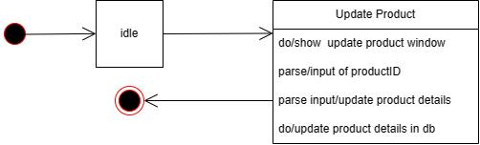

***Fig(5***)

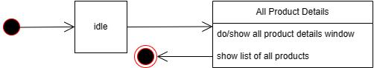

***Fig(6***)

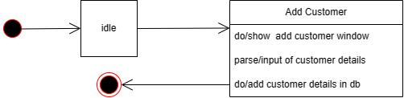

***Fig(7***)

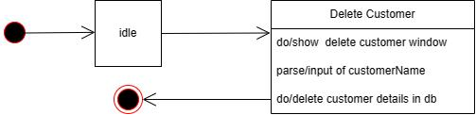

***Fig(8***)

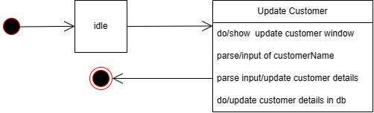

***Fig(9***)

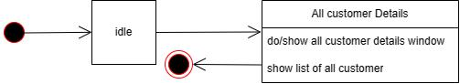

***Fig(10***)

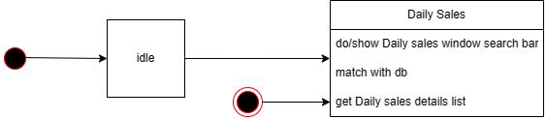

***Fig(11***)

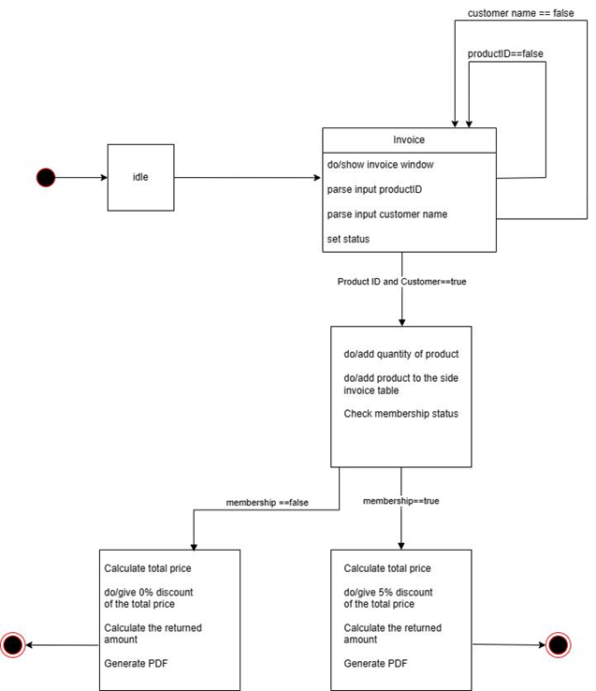

***Fig(12***)

Data flow diagram:

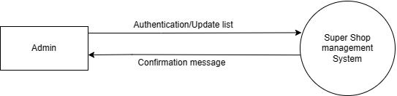

***Fig(1***)

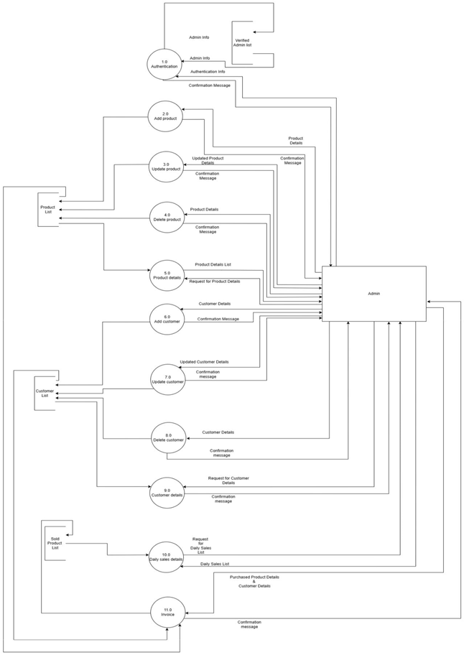 ***Fig(2***)

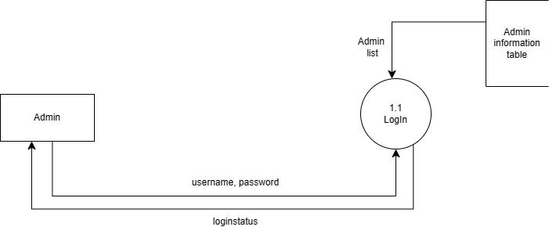

***Fig(3***)

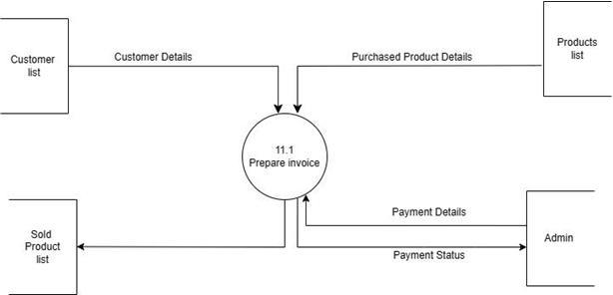

***Fig(4***)

Sequence diagram:

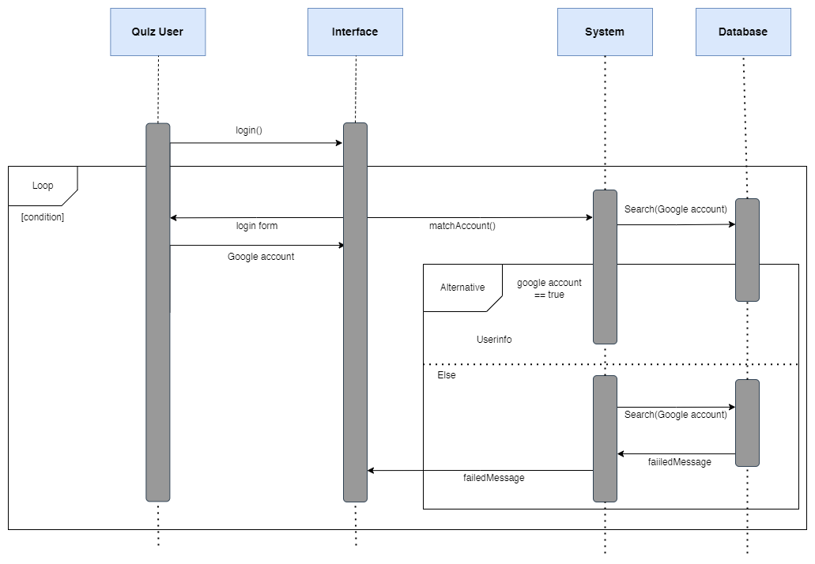

***Fig(1***)

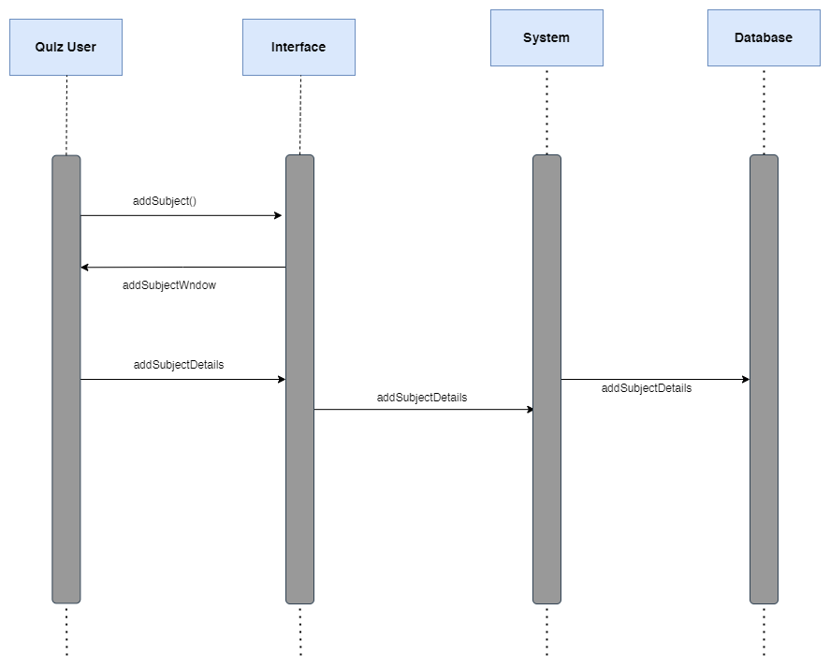

***Fig(2***)

# Function point Ranking According to Complexity

|  |  |  |  |
| --- | --- | --- | --- |
| **Measurement Parameter** | **Low** | **Average** | **High** |
| 1. Number of external inputs (EI) | 7 | 10 | 15 |
| 2. Number of external outputs (EO) | 5 | 7 | 10 |
| 3. Number of external inquiries (EQ) | 3 | 4 | 6 |
| 4. Number of internal files (ILF) | 4 | 5 | 7 |
| 5. Number of external interfaces (EIF) | 3 | 4 | 6 |

**Table 1.1:** Weights of 5-FP Attributes

**1. External Inputs (EIs):**

* Quiz User: (Low)
* Add new Subject details: (Low)
* Update subject details: (Average)
* Show subject details (Average)
* Remove subject details: (Average)
* Add new Topic details: (Low)
* Update Topic details: (Average)
* Show Topic Details (Average)
* Remove Topic details: (Average)
* Add new Chapter details: (Low)
* Update Chapter details: (Average)
* Show Chapter Details (Average)
* Remove Chapter details: (Average)
* Add new Content details: (Low)
* Take Test: (Average)
* Remove Content details: (Average)
* Add to my list: (Low)
* Remove contents (Average)
* Create Test: (Low)
* Name of the Test: (Average)
* Update Test: (Average)
* Show Test Details (Average)
* Remove Test: (Average)
* End Test: (Average)
* Summary: (High)

**Total Weighing Factor for EI:** 7 * 6 + 10 * 16 + 15 * 1 = 217

**2. External Outputs (EOs):**

* Add new Subject details: (Low)
* Update subject details: (Average)
* Show subject details (Average)
* Remove subject details: (Average)
* Add new Topic details: (Low)
* Update Topic details: (Average)
* Show Topic Details (Average)
* Remove Topic details: (Average)
* Add new Chapter details: (Low)
* Update Chapter details: (Average)
* Remove Chapter details: (Average)
* Add new Content details: (Low)
* Take Test: (Average)
* Remove Content details: (Average)
* Add to my list: (Low)
* Remove contents (Average)
* Create Test: (Low)
* Name of the Test: (Average)
* Update Test: (Average)
* Show Test Details (Average)
* Remove Test: (Average)
* End Test: (Average)
* Summary: (High)

**Total Weighing Factor for EO:** 5 * 7 + 7 * 14 + 10 * 1 = 143

**3. External Inquiries (EQs):**

* Show Subject details: (Low)
* Show Topic details: (Low)
* Show Chapter details: (Low)
* Take Test:(Average)
* End Test: (Average)

**Total Weighing Factor for EQ:** 3 * 3 + 4 * 2 + 6 * 0 = 17

**4. Internal Logical Files (ILFs):**

* Admin: (Low)
* Product Information Management: (Low)
* Customer Information Management: (Low)
* Category Information management: (Low)
* Daily Sales Management: (Average)

**Total Weighing Factor for ILF:** 4 * 4 + 5 * 1 + 7 * 0 = 21

**5. External Interface Files (EIF):**

* Invoice PDF: (High)

**Total Weighing Factor for EIF:** 3 * 0 + 4 * 0 + 6 * 1 = 6

|  |  |
| --- | --- |
| **Measurement Parameter** | **Weighing Factor** |
| 1. Number of external inputs (EI) | 127 |
| 2. Number of external outputs (EO) | 71 |
| 3. Number of external inquiries (EQ) | 17 |
| 4. Number of internal files (ILF) | 21 |
| 5. Number of external interfaces (EIF) | 6 |
|  | **Total Count**: 242 |

**Table 1.2:** Computing weighing factor

So, **UFP** = 242

Calculate Complexity Adjustment Factor (CAF)

# 

|  |  |
| --- | --- |
| **General System Characteristics (GSC)** | **Degree Of Influence (DI) (0-5)** |
| 1.Data Communications | 2 |
| 2.Distributed Data Processing | 1 |
| 3.Performance | 3 |
| 4.Heavily User Configuration | 0 |
| 5.Transaction Rate | 4 |
| 6.Online Data Entry | 5 |
| 7.End-User Efficiency | 5 |
| 8.Online Update | 2 |
| 9.Complex Processing | 2 |
| 10.Reusability | 1 |
| 11.Installation Ease | 4 |
| 12.Operational Ease | 4 |
| 13.Multiple Sites | 0 |
| 14.Facilitate Change | 3 |
| **Total degree of influence** | **TDI**: 36 |

**Table 2:** 14-factors

So, **CAF** = [0.65 + (0.01 * **TDI**)] = [0.65 + (0.01 * 36)] = 1.01

# Calculate Functional Points (FP)

So, **FP** = **UFP** * **CAF** = 242 * 1.01 = 244.42

Benchmarking:

1.Sowpnil Roy (20200104071): 38% contribution

* UI - UX Design
* Home Page Design
* Report Writing
* Database Design
* Sequence Diagram
* Swimlane Diagram
* Registration & Logout
* Function Point estimation

2.Hridia Hridi (20200104052): 32% contribution

* Report Writing
* Database Design
* Registration & Logout
* Entity Relation Diagram
* Authentication and Authorization
* Database Implementation
* Class Diagram

3.Jannatul Maowa Ahona (20200104055): 30% contribution

* Report Writing
* Database Design
* Use case Diagram
* Registration & Logout
* Entity Relation Diagram
* Authentication and Authorization

Conclusion:

A quiz game is an engaging and educational form of entertainment. With various quiz categories and challenging questions, it tests players' knowledge and offers a fun experience. Users can register, log in, and select their preferred category. Questions are presented one at a time with multiple-choice options, allowing users to make their selections. Scoring is based on correct answers, motivating players to aim for high scores. Error handling ensures a smooth experience, and performance optimization provides seamless gameplay. A quiz game combines entertainment, learning, and competition, making it an enjoyable activity for players of all ages.